Git and GitHub
Version control System (VCS):
Tool or software that helps you to track changes made to files over time. It lets you:
- Save different versions of projects
- Go back to an earlier version
- Work with team
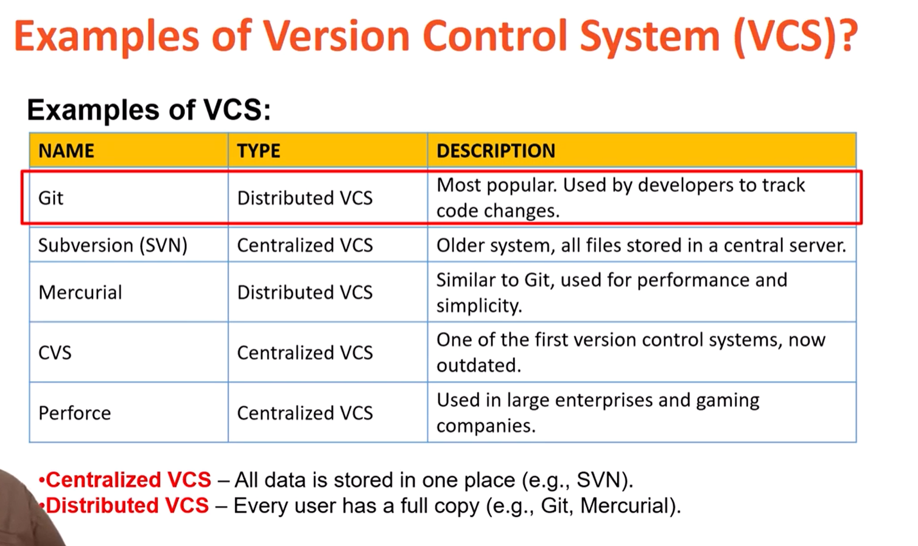
- See who made change what and when
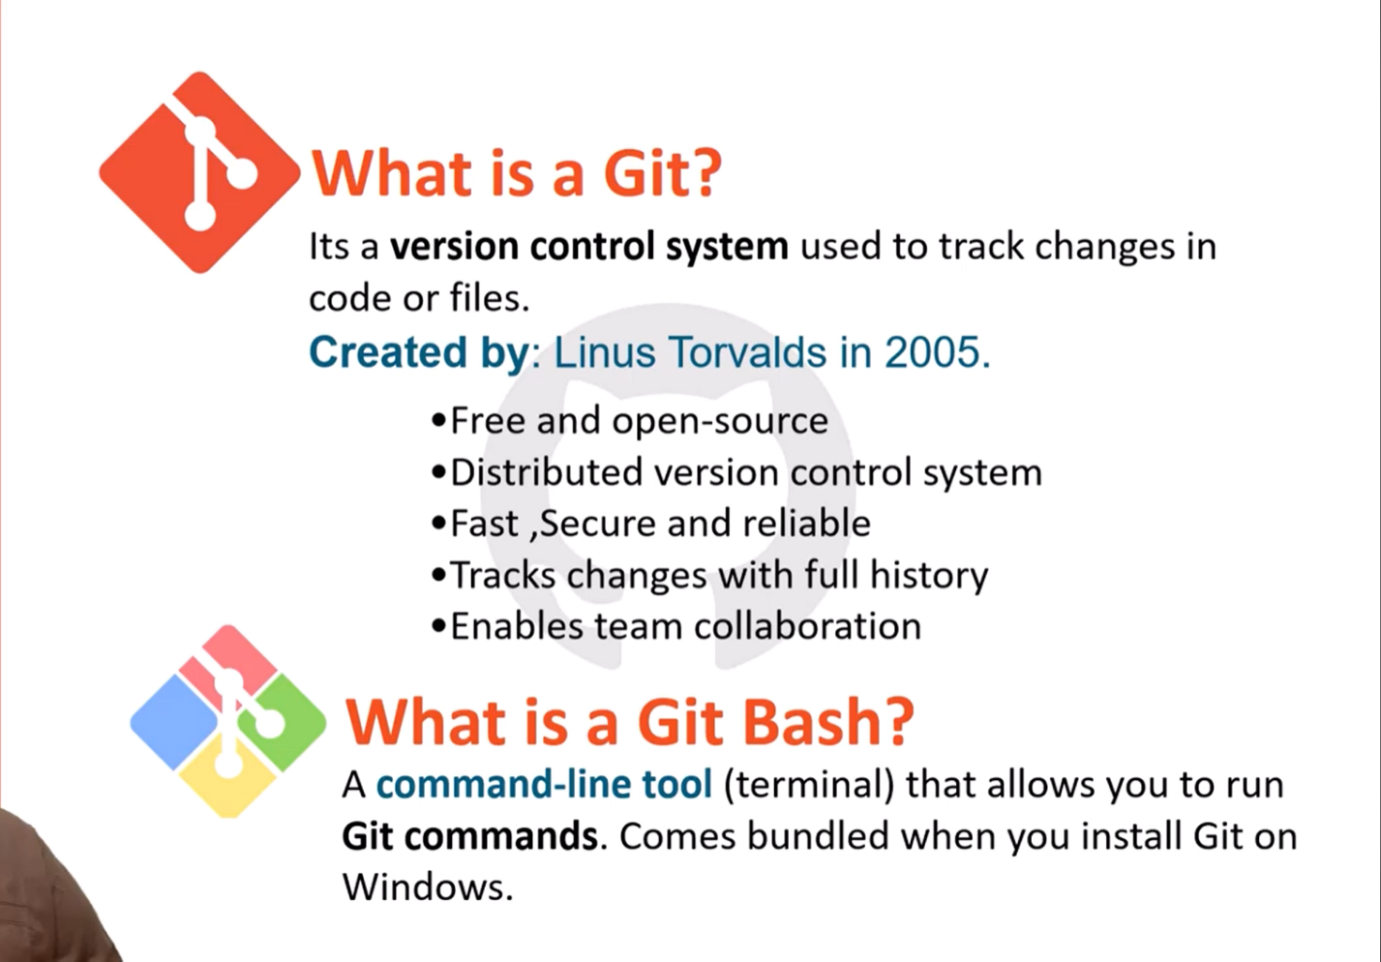
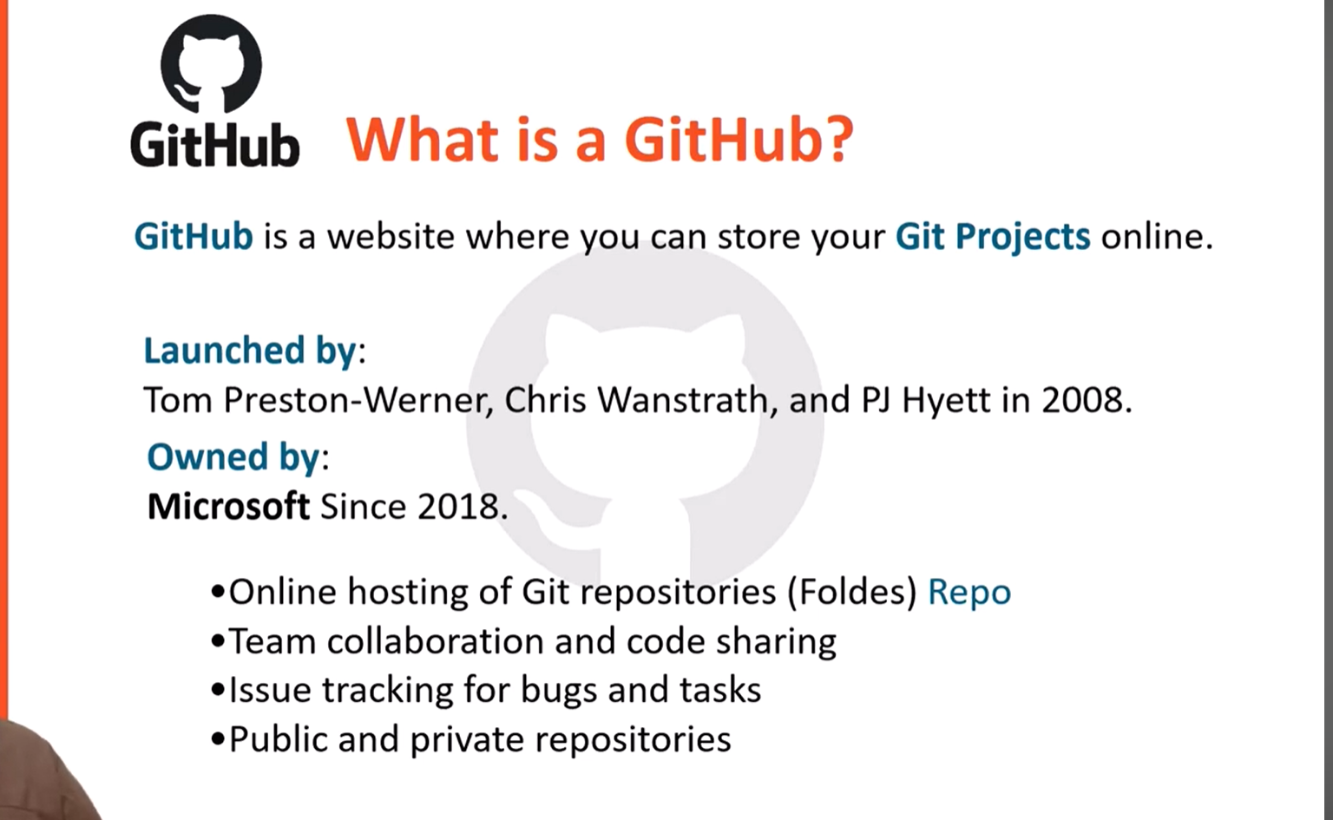
Things to do
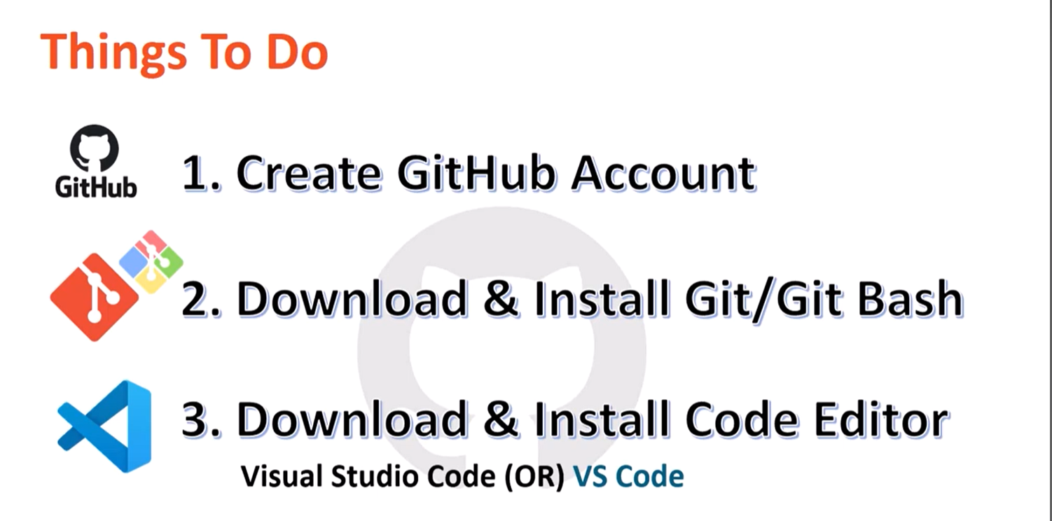
What is GitHub Repository:

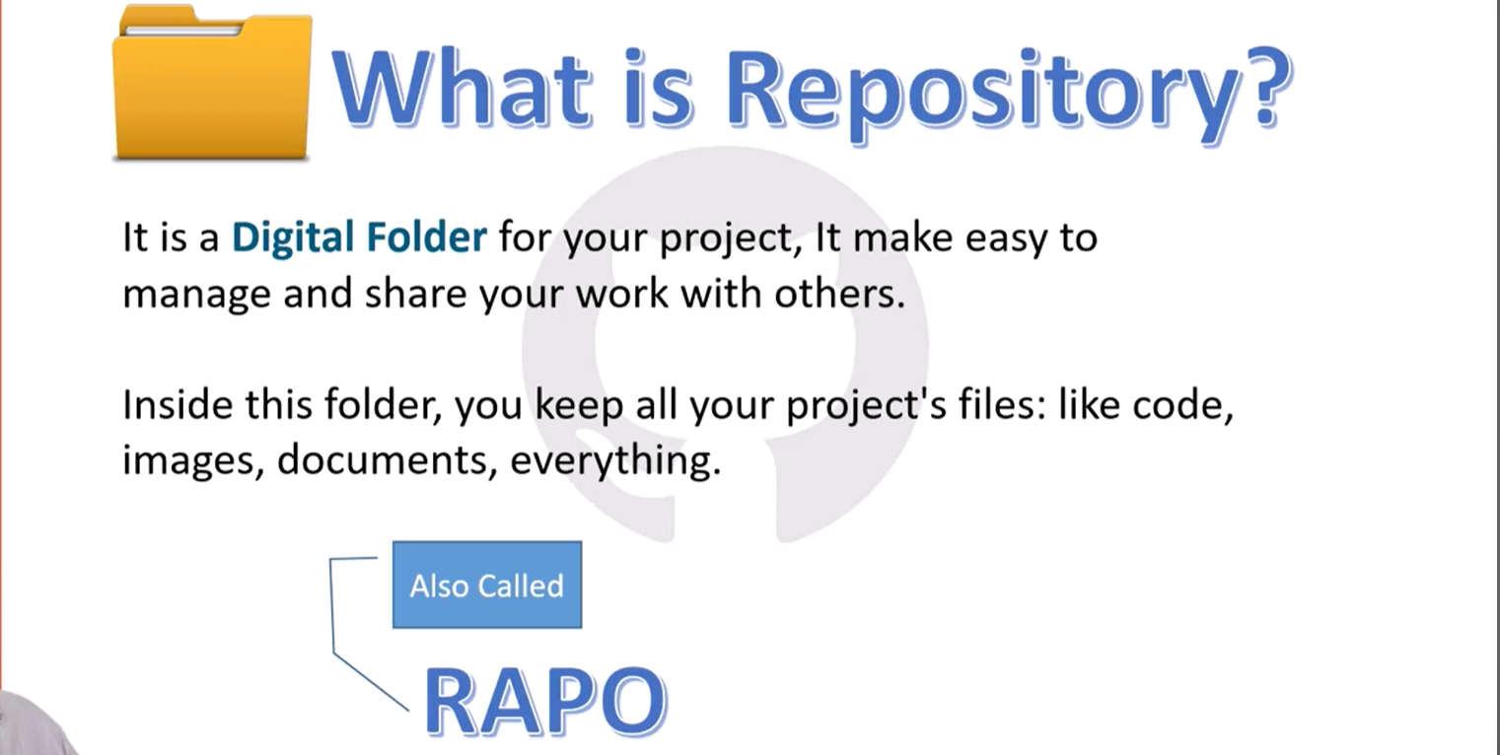

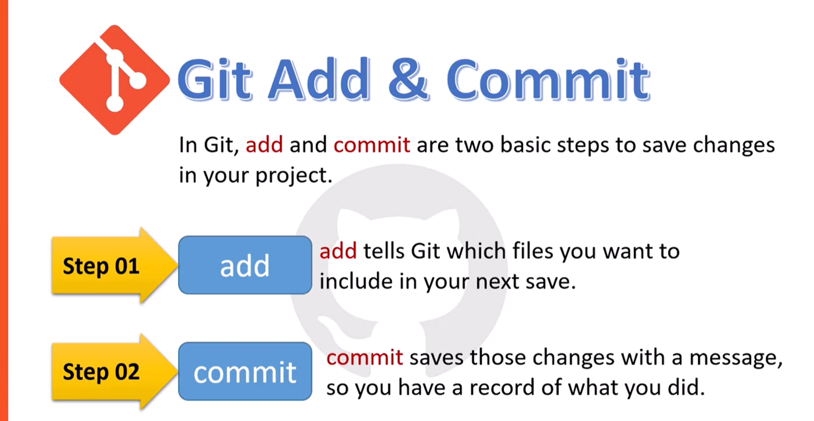
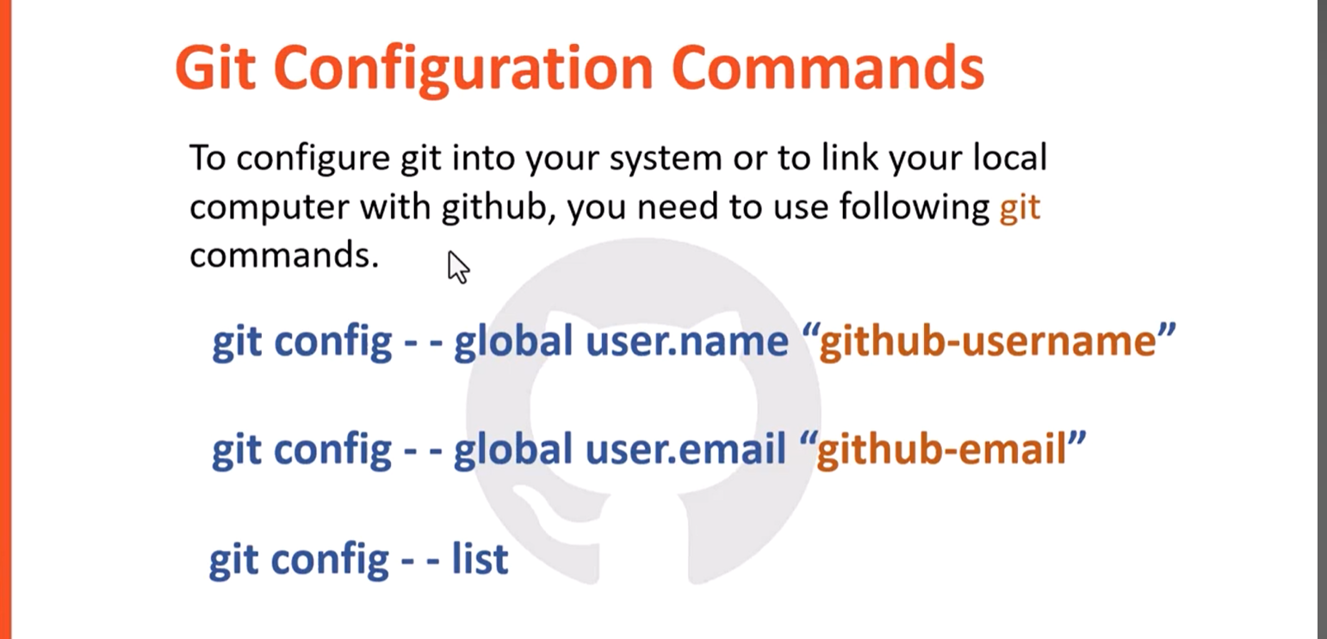

git config --global user.name "bilalramzan01"

We’ll walk through: git config --global user.name "Your Name"
git config --global user.email "bilalramzan.cs@gmail.com"
git config --global --list
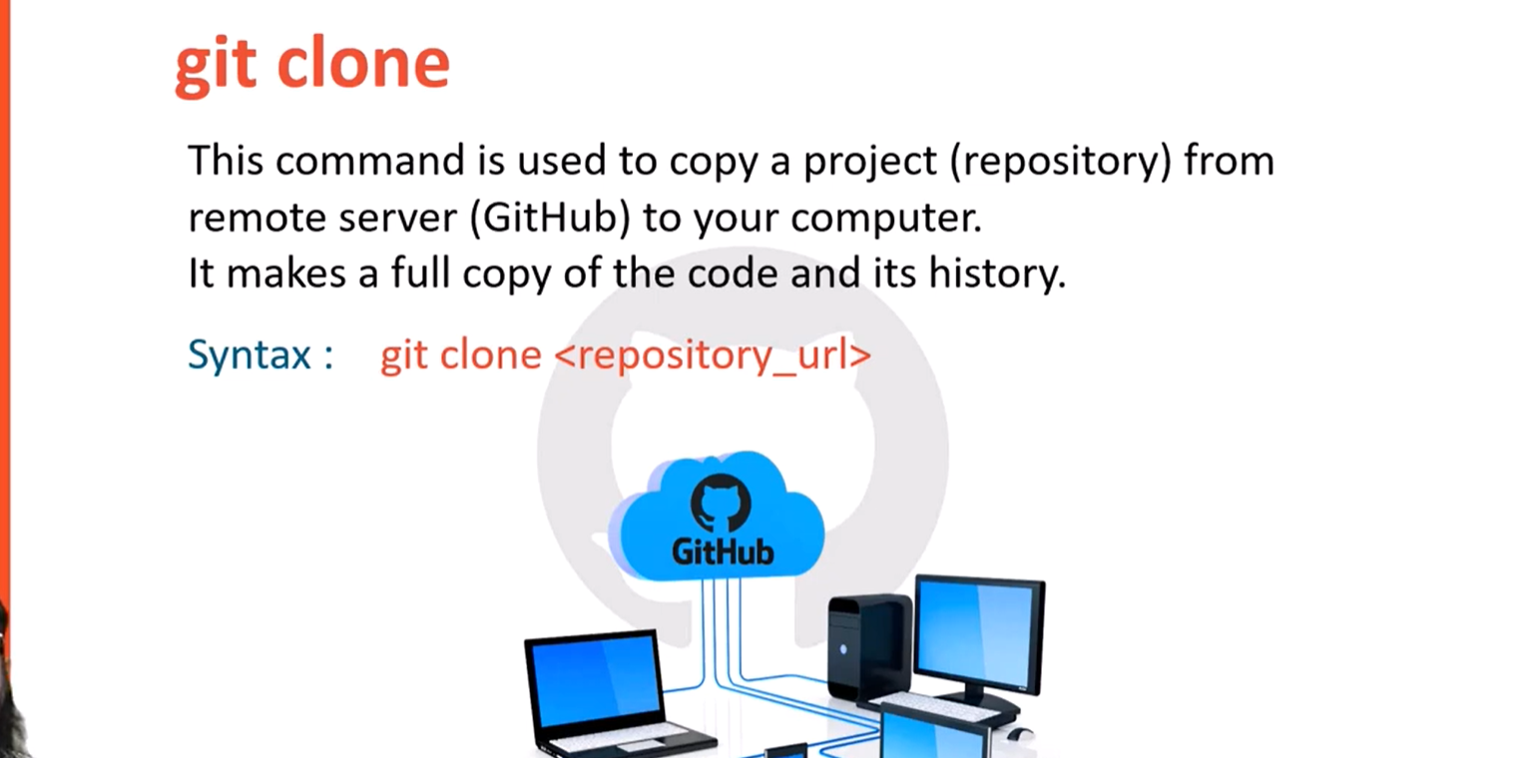

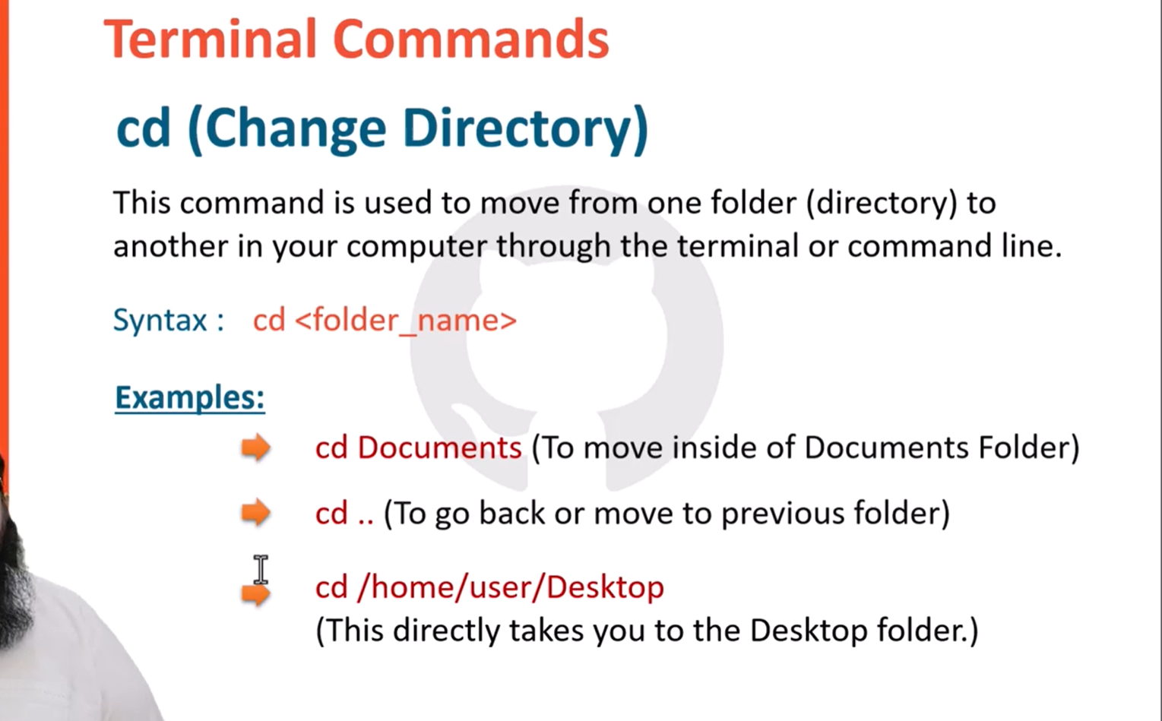
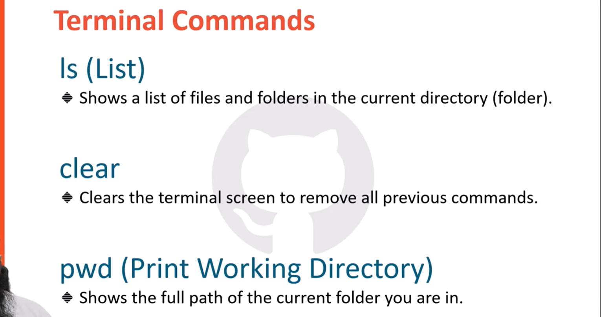

git clone
Purpose: Download an existing repository from GitHub to your computer.
git clone https://github.com/user/repo.git

git status
Purpose: Check the current state of your repository.
git status
📌 Shows:
- modified files
- staged files
- untracked files
git add
Purpose: Add files to the staging area before committing.
git add file.txt

git commit
Purpose: Save changes permanently in Git.
git commit -m "Added login page"
📌 Always write a meaningful message.

git push
Purpose: Upload local commits to GitHub.
git push origin main
📌 Sends your code to the remote repository.

git pull
Purpose: Download the latest changes from GitHub.
git pull origin main
📌 Updates your local repository.

git branch
Purpose: Show or create branches.
Show branches:
git branch
Create new branch:
git branch feature-login

git checkout
Purpose: Switch between branches.
git checkout feature-login

git merge
Purpose: Combine branches.
git merge feature-login

